Ex.no:2 | EDA-DATA IMPORT AND EXPORT

Aim:
To inspect dataset features, detect null values, and export data into CSV, Excel, and SQLite database formats.

Algorithm:

Import the required libraries, pandas and sqlite3.

Read games.csv using pd.read_csv() and store the data in a Pandas DataFrame.

Inspect the dataset structure using .head(), .tail(), .info(), .describe(), and .isnull().sum().

Export the DataFrame into .csv and .xlsx formats using .to_csv() and .to_excel().

Connect to chess_games.db using sqlite3 and write the chess-game data into an SQL table using .to_sql().

Close the SQLite database connection and end the execution.

Program:
import os
import pandas as pd
import numpy as np

path = "."

print("\nDataset path:", path)

print("\nFiles in dataset:")
print(os.listdir(path))

csv_files = [
f for f in os.listdir(path)
if f.lower().endswith(".csv")
]

if not csv_files:
raise FileNotFoundError(
"No CSV file found in the dataset path."
)

# Select the games CSV file
games_files = [
f for f in csv_files
if "games" in f.lower()
]

if not games_files:
raise FileNotFoundError(
"No games CSV file found in the dataset path."
)

csv_file = games_files[0]

print("\nCSV file:", csv_file)

df = pd.read_csv(
os.path.join(path, csv_file)
)

# First 5 and Last 5 Rows

print("\nFirst 5 rows:")
display(df.head())

print("\nLast 5 rows:")
display(df.tail())

# Dataset Information

print("\nDataset information:")
df.info()

print("\nShape:")
print(df.shape)

print("\nColumns:")
print(df.columns.tolist())

print("\nData types:")
print(df.dtypes)

# Statistical Description

print("\nStatistical description:")
display(df.describe(include="all").T)

# Missing Values

print("\nMissing values:")

display(
df.isnull().sum()
.sort_values(ascending=False)
)

# Duplicate Rows

print("\nDuplicate rows:")
print(df.duplicated().sum())

# Rated Games

print("\nRated games:")
display(
df["rated"].value_counts()
)

# Victory Status

print("\nVictory status:")
display(
df["victory_status"].value_counts()
)

# Winner

print("\nWinner:")
display(
df["winner"].value_counts()
)

# Opening ECO

print("\nOpening ECO:")
display(
df["opening_eco"].value_counts().head(10)
)

# Gender-wise equivalent:
# Analyze winner-wise game counts

print("\nWinner-wise game counts:")
display(
df.groupby("winner")
.size()
.sort_values(ascending=False)
)

# Victory Status-wise Analysis

print("\nVictory status-wise game counts:")
display(
df.groupby("victory_status")
.size()
.sort_values(ascending=False)
)

# Create Rating Difference

df["Rating_Difference"] = abs(
df["white_rating"] - df["black_rating"]
)

print("\nRating Difference:")
display(
df[
[
"white_rating",
"black_rating",
"Rating_Difference"
]
].head()
)

# Rating Difference Groups

df["Rating_Group"] = pd.cut(
df["Rating_Difference"],
bins=[-1, 100, 300, 500, float("inf")],
labels=[
"Low Difference",
"Moderate Difference",
"High Difference",
"Very High Difference"
]
)

print("\nRating group-wise game counts:")
display(
df.groupby(
"Rating_Group",
observed=False
).size()
)

# Average Number of Turns by Winner

print("\nAverage number of turns by winner:")

display(
df.groupby("winner")["turns"]
.mean()
)

# Average White Rating by Winner

print("\nAverage White rating by winner:")

display(
df.groupby("winner")["white_rating"]
.mean()
)

# Average Black Rating by Winner

print("\nAverage Black rating by winner:")

display(
df.groupby("winner")["black_rating"]
.mean()
)

# Average Rating Difference by Winner

print("\nAverage rating difference by winner:")

display(
df.groupby("winner")["Rating_Difference"]
.mean()
)

# Opening-wise Game Analysis

print("\nTop 10 opening names:")

display(
df.groupby("opening_name")
.size()
.sort_values(ascending=False)
.head(10)
)

# Average Game Length by Victory Status

print("\nAverage turns by victory status:")

display(
df.groupby("victory_status")["turns"]
.mean()
.sort_values(ascending=False)
)

# Correlation Analysis

print("\nCorrelation:")

display(
df[
[
"turns",
"white_rating",
"black_rating",
"opening_ply",
"Rating_Difference"
]
].corr()
)

# Winner Percentages

total_games = len(df)

white_wins = (
df["winner"] == "White"
).sum()

black_wins = (
df["winner"] == "Black"
).sum()

draws = (
df["winner"] == "Draw"
).sum()

white_percentage = (
white_wins / total_games
) * 100

black_percentage = (
black_wins / total_games
) * 100

draw_percentage = (
draws / total_games
) * 100

print("\nWinner Percentages:")

print(
"White Win Percentage:",
round(white_percentage, 2),
"%"
)

print(
"Black Win Percentage:",
round(black_percentage, 2),
"%"
)

print(
"Draw Percentage:",
round(draw_percentage, 2),
"%"
)

# Create Outcome Percentage Column

df["Winner_Percentage"] = df["winner"].map({
"White": white_percentage,
"Black": black_percentage,
"Draw": draw_percentage
})

print("\nWinner Percentage column:")

display(
df[
[
"winner",
"turns",
"white_rating",
"black_rating",
"Winner_Percentage"
]
].head()
)

# Export Dataset

df.to_excel(
"games_data.xlsx",
index=False
)

df.to_json(
"games_data.json",
orient="records",
indent=4
)

df.to_csv(
"games_data.csv",
index=False
)

print(
"\nCSV, Excel and JSON files created successfully."
)

Output:
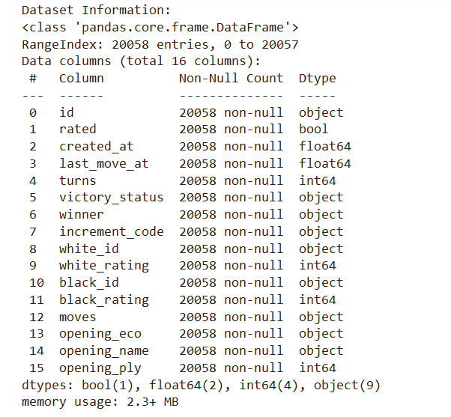

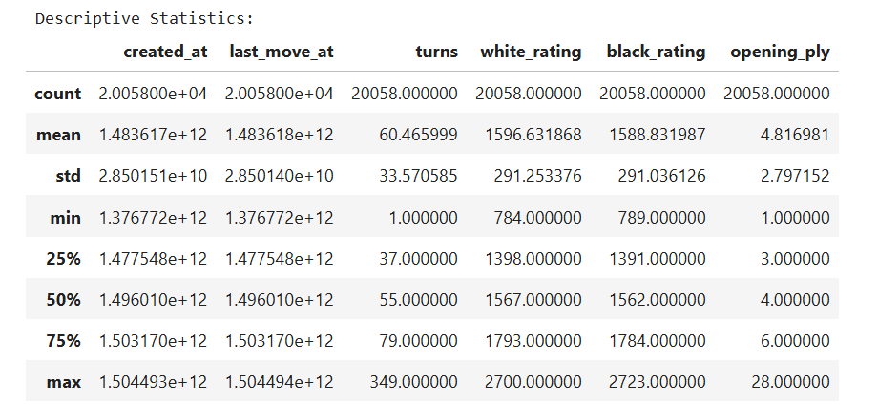

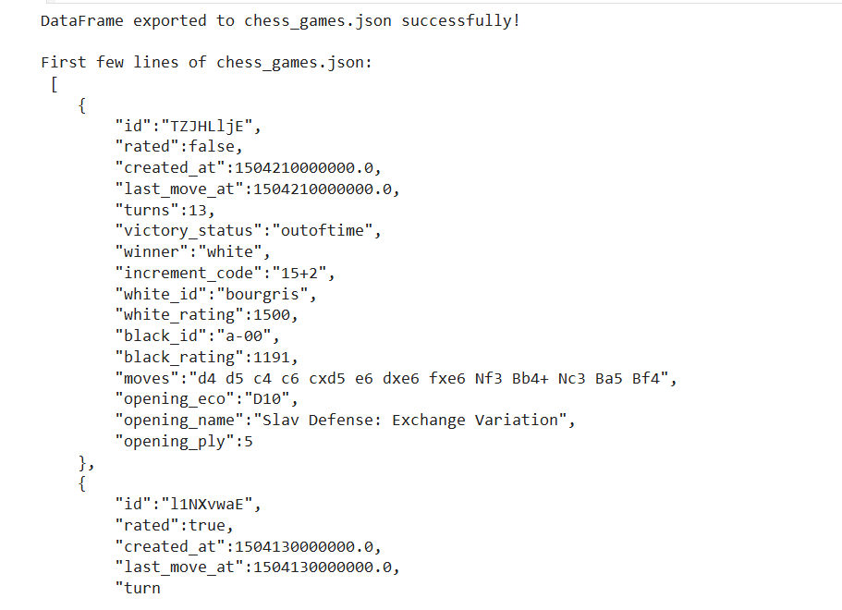
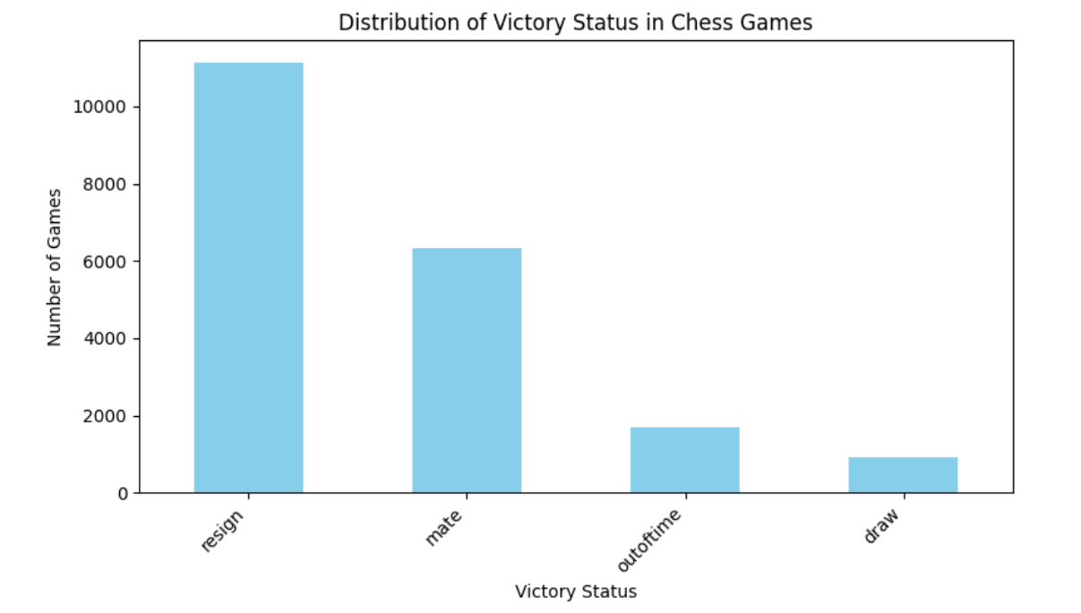

Result:

